How to create a shortcut for Git Bash on your Desktop

(*) There is a doc to describe the creation of a folder

(**)There is a doc to describe the removal of a file

Since I had some trouble to move file from one folder (*) to another, here is the results of what I have found:

1. Move the file on your computer, as you would normally do
2. Open git bash:

$ git add . (yes, there is a dot)

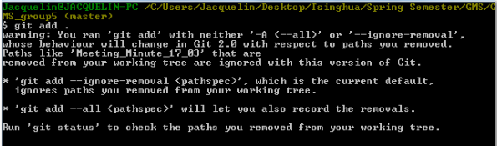

1. You can aks for a git status: the bash says then that the file has been moved to the new folder (green = operation done), and that it is kinda removed from the old one. This might not be systematic, the bas may say that the file moved has just been renamed from old_folder_name/file_name to new_folder_name/file_name (green). I frankly haven’t found out yet why and when. What you have to know is how to react to the situation when the removed file is noted “deleted” in red:

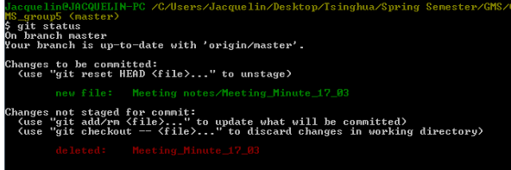

1. So this is what you have to do: remove(**) manually the file that is noted as deleted.

$ git rm “name of the file”

1. Now git has understood that you have actually moved the file from one folder to another, since there is no trace of it in the old one anymore:

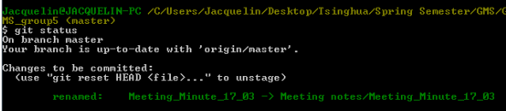

1. Finnish him!

$ git commit –m “moving file from ## to ###”

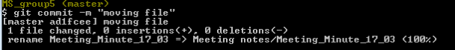

1. Fatality!

$ git push

Now everything is uploaded to git. You’re the best.

Here is the entire process:

